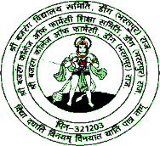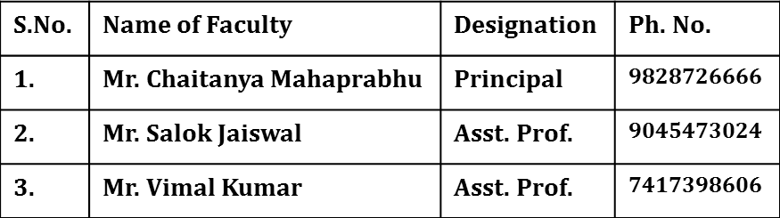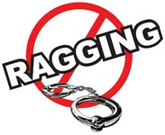

**SHRI BAJRANG COLLEGE OF PHARMACY**

**Bhuda Gate, Deeg, Bharatpur (Raj.)**

**Approved by AICTE, PCI & Affiliated to RUHS, Jaipur (Raj.)**

**DON’T ‘RAG’**

**Also**

**DON’T BE A**

**MUTE WITNESS TO ‘RAGGING’**

**What is Ragging ?**

**Any act resulting in :**

* **Mental/Physical/Sexual abuse**
* **Verbal abuse**
* **Indecent Behaviour**
* **Criminal intimidatiom/Wrongful restraint**
* **Undermining human dignity**
* **Financial exploitation/Extortion**
* **Use of force**

**Each of the above is a criminal offence**

**ANTI-RAGGING SQUAD**

A Student involved in ragging be :

* **Expelled from the institution**
* **Banned from the mess/Hostel**
* **His/her Scholarship can be withdrawn**
* **Debarred from examinations**
* **Denied admission to any institution**
* **Prosecuted for criminal action**
* **Institutions to file FIR with local police against**

**Those who RAG/ABET ragging**

**Join Hands to Make Ragging Free Campus**